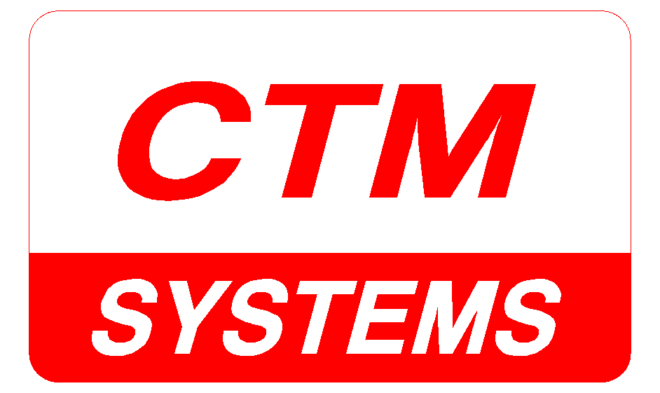

Quality Policy Statement
CTM Systems Limited, based in South Bedford, is a long-established manufacturer of high quality stainless steel and mild steel process handling and material conveying systems for the Waste Water, Potable Water, Food Processing, Chemical and Quarrying Industries using a wealth of engineering and application expertise.
Full installation, modification and refurbishment packages of both CTM and non-CTM equipment can also be undertaken.
CTM Systems are committed to delivering a quality products and service to our customers.
The company operates within the following systems:
  - Quality Management System in accordance with ISO9001:2015
  - Achilles Supplier Accreditation
  - Safe Contractor
The company ensures that resources are available to maintain compliance with the Quality Management Systems and Schemes identified to satisfy all applicable legal and regulatory requirements.
The Management are committed to continually improving the Quality Systems and Accreditations to enhance performance. They will do this through setting objectives and monitoring the results. Objectives are in line with the companies Vision Statement which is outlined below:
  - To be the UK leader in providing innovative, robust products, solutions and spares primarily for the water industries.
  - Ensure excellent customer service, project management and ongoing relationships with our customers and suppliers.
  - Maintain a ‘family business culture’ for our employees
  - Withstand the challenges which the pandemic has placed up on the operations of the business.
This Quality policy is available to all employees on the shared drive and on relevant notice boards. This policy is available to external interested parties on request.

This statement will be reviewed on or before 12/6/22.

Signed: 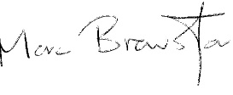 Date: 12/6/21
For and on behalf of CTM Systems Limited

